**Ideation Phase**

**Define the Problem Statements**

|  |  |
| --- | --- |
| Date | 31 January 2025 |
| Team ID | LTVIP2025TMID55709 |
| Project Name | ShopEZ:One-Stop Shop For Online Purchases |
| Maximum Marks | 2 Marks |

**Customer Problem Statement Template:**

**1️⃣ Customer Segment:**

Small and medium shop owners and local sellers who want to sell their products online but lack the technical resources to build or maintain an e-commerce platform.  
Buyers looking for a convenient, user-friendly platform to browse, add to cart, and purchase products from local sellers online.

**2️⃣ Customer Needs:**

* A **platform to showcase and manage products online** without advanced technical knowledge.
* Ability to **receive and manage customer orders digitally.**
* Buyers need a **simple, secure, and smooth checkout experience**.
* A **mobile-responsive design** for customers to shop from anywhere.
* Secure user authentication for **safe transactions** and personalized experiences.

**3️⃣ Problem Statement:**

**Local sellers and small businesses face challenges in showcasing their products online and managing customer orders digitally, leading to limited reach and reduced sales opportunities. Buyers find it difficult to discover, browse, and purchase products from local sellers online in a secure and user-friendly environment.**

**4️⃣ Impact on Customers:**

✅ **For Sellers:**

* Loss of potential customers due to the absence of an online presence.
* Difficulty in managing inventory and orders manually.
* Inability to track customer preferences and order history for personalized engagement.

✅ **For Buyers:**

* Limited access to local products online.
* Hassles in finding reliable sellers and managing purchases manually.
* Lack of seamless checkout and order tracking experiences.

**5️⃣ Why Solving This is Important:**

* **Empowers local sellers** to increase their reach, visibility, and sales using a simple, ready-to-use e-commerce platform.
* **Facilitates buyers** with a convenient, secure, and smooth online shopping experience with local products.
* **Bridges the technology gap** for small sellers in moving towards digitization.
* Promotes local businesses and supports the community economy.

**6️⃣ Summary:**

**We aim to build a user-friendly, full-stack e-commerce platform using the MERN stack that enables small and local sellers to list and manage their products online and allows buyers to browse, add to cart, and securely purchase these products conveniently, helping local businesses expand their reach and improving customer shopping experiences.**

|  |  |  |  |  |  |
| --- | --- | --- | --- | --- | --- |
| **Problem**  **Statement (PS)** | **I am**  **(Customer)** | **I’m trying to** | **But** | **Because** | **Which makes me feel** |
| PS-1 |  |  |  |  |  |
| PS-2 |  |  |  |  |  |

A well-articulated customer problem statement allows you and your team to find the ideal solution for the challenges your customers face. Throughout the process, you’ll also be able to empathize with your customers, which helps you better understand how they perceive your product or service.

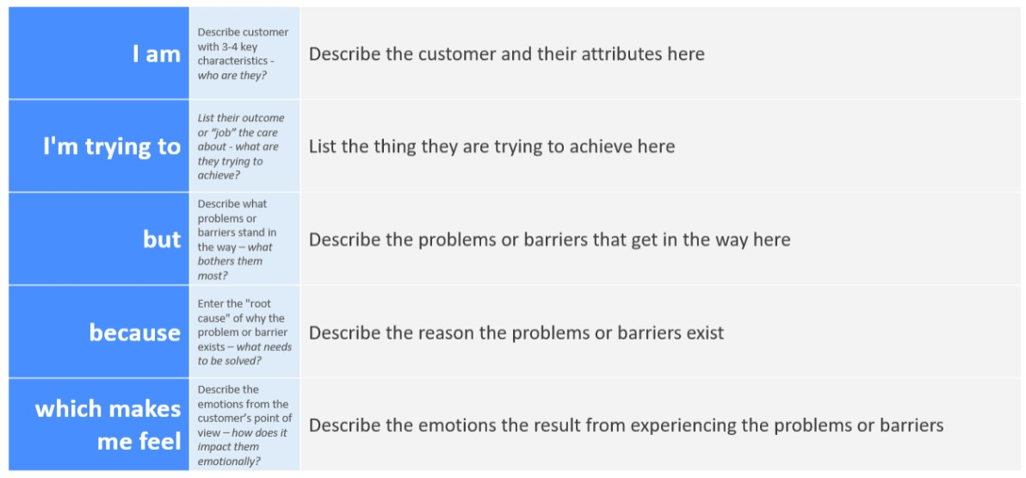

Reference: <https://miro.com/templates/customer-problem-statement/> **Example:**

